DURHAM COLLEGE

ASSIGNMENT 1- STATISTICS

Name: Hisham Mohammed Afzal

Student ID: 100905717

Contents

**1.Hypothesis Statement:** 1

**2. Normality of the Dataset-** 1

**3. Step-by-step outline** 3

**4. Analysis:** 4

**5. Summary of Findings and Conclusion:** 5

**6. References** 6

# **Hypothesis Statement:**

If the certain diet program is applied to an individual for the past 6 months, then there can be change in an individual’s cholesterol levels.

# **2. Normality of the Dataset-**

Code-

# Store the data in the variable my_data

my_data <- CholestrolLevel

my_data

#QQ Plot

qqnorm(CholestrolLevel$After, pch = 1, xlab = "Level of Cholestrol after diet plan", ylab = "Patient")

qqline(CholestrolLevel$After, col = "blue", lwd = 2)

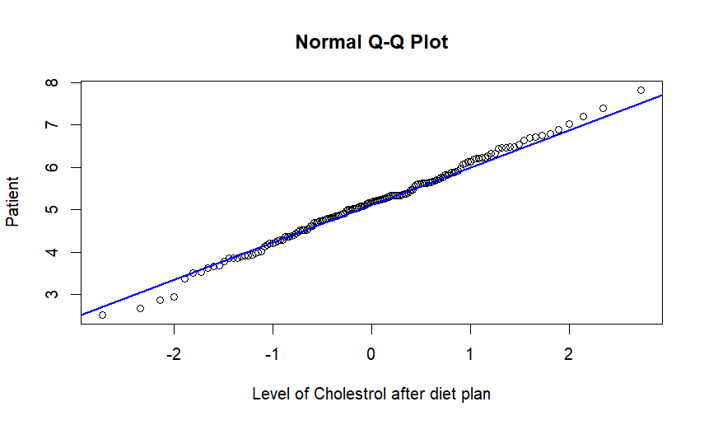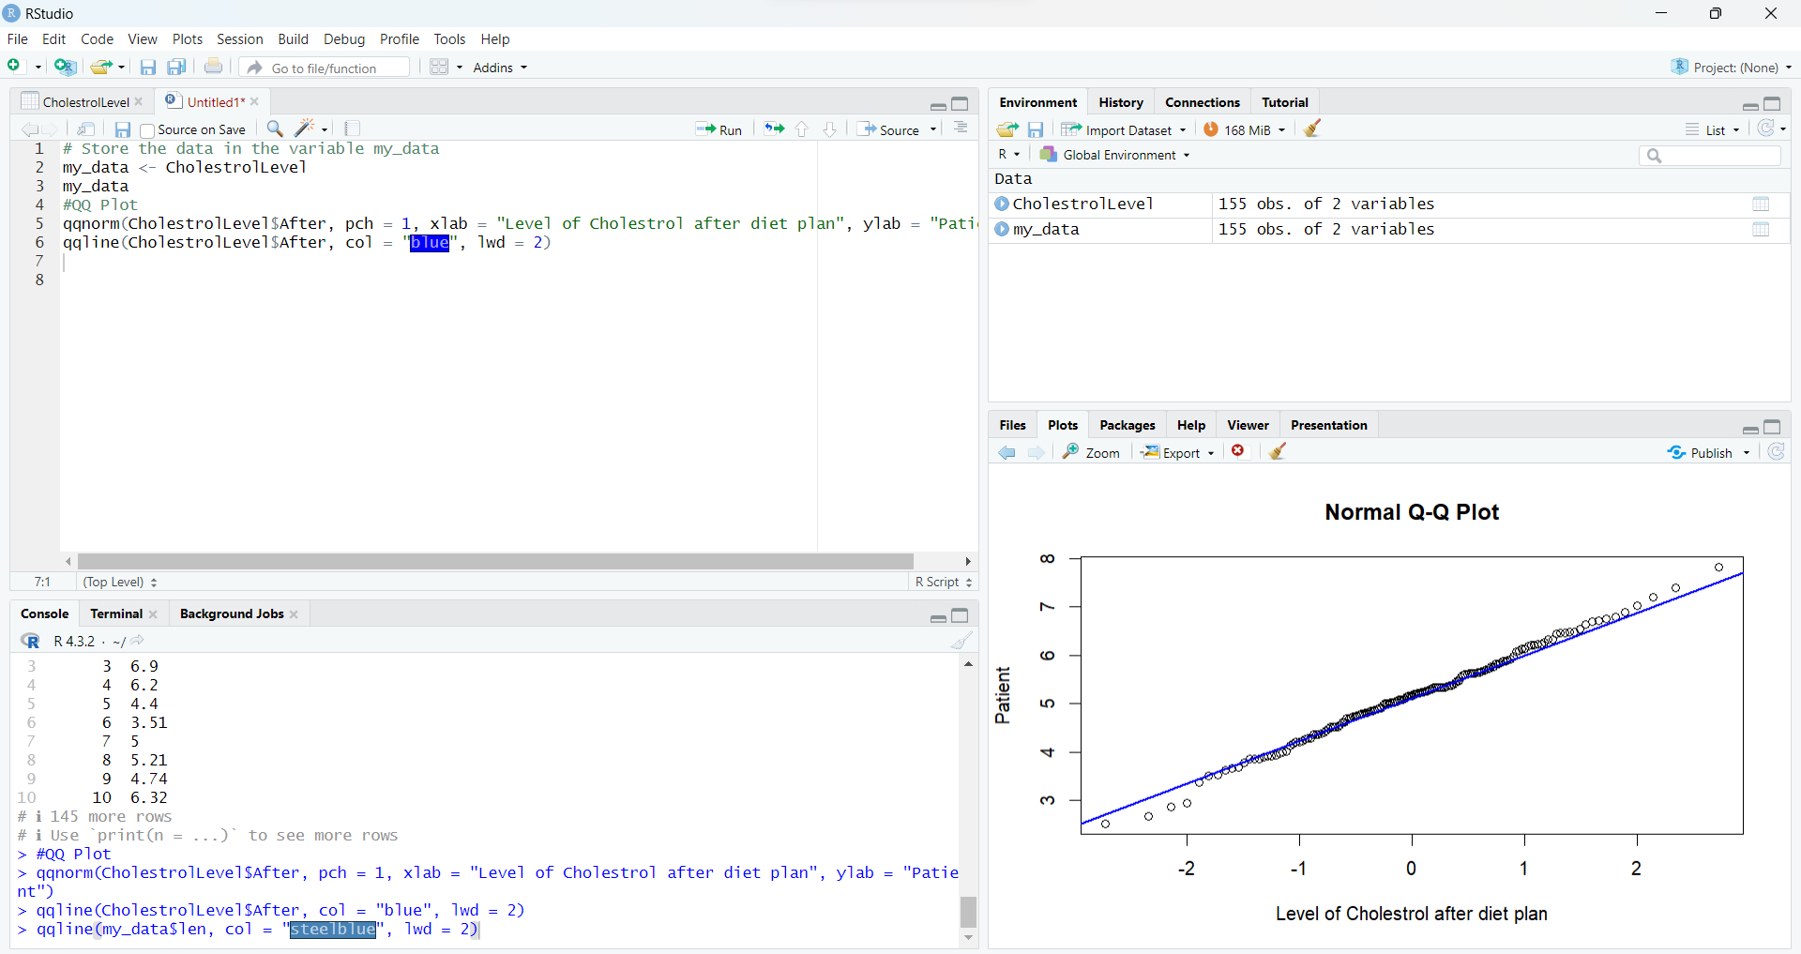

#Shapiro-Wilk Test

shapiro.test(CholestrolLevel$After)

data: CholestrolLevel$After

W = 0.99595, **p-value = 0.95**

P-value is greater than 0.05, hence the distribution is normal. The dataset of cholesterol levels shows no significant deviation from a normal distribution

# **3. Step-by-step outline**

Step 1 - State the null and alternative hypothesis α

Null Hypothesis: If the certain diet program is applied to an individual for the past 6 months, then there is no change in an individual’s cholesterol levels

Alternate Hypothesis: If the certain diet program is applied to an individual for the past 6 months, then there should be change in an individual’s cholesterol levels

Step 2. Specify a significance level z

The significance level assumed in this case is 0.05

Step 3. Compute the test statistic z

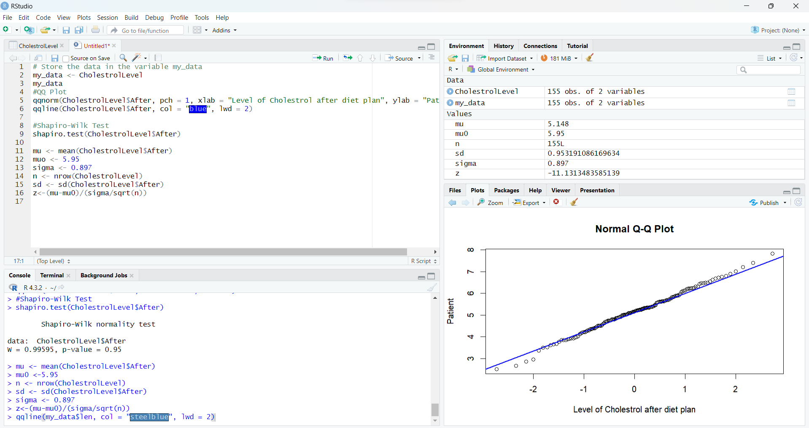

mu <- mean(CholestrolLevel$After)

muo <- 5.95

sigma <- 0.897

n <- nrow(CholestrolLevel)

sd <- sd(CholestrolLevel$After)

z<-(mu-mu0)/(sigma/sqrt(n))

Z=-11.1

Step 4. Assuming the null is true and make a decision by:   
o Comparing the test statistic z with the critical value or values   
o Comparing the p-value with the significance value α

**P-value** by calculating using Z value is **8.828976e-29**

which is extremely small, it is far below the assumed significance level of

0.05

Decision:

**Comparing the test statistic with critical value**: The absolute value of the calculated Z statistic (-11.1) is well beyond the critical values for a two-tailed test at a significance level of 0.05, leading to the rejection of the null hypothesis.

**Comparing the p-value with the significance level** **(α)**: The p-value (8.83e-29) is much smaller than the chosen significance level of 0.05, further supporting the rejection of the null hypothesis.

Step 5. State your conclusion

**Conclusion-**

Hence, based on both the critical value approach and the p-value approach, we reject the null hypothesis. There is significant evidence to suggest that applying the certain diet program to individuals for the past 6 months has led to a change in their cholesterol levels.

# **4. Analysis:**

After rigorously examining the data using both the critical value and p-value approaches, we find substantial grounds to reject the initial idea that there is no impact on individuals' cholesterol levels after implementing a specific diet program for the past 6 months. The results strongly indicate that the diet program has indeed brought about a meaningful change in cholesterol levels. The evidence gathered from the statistical analysis provides confidence in supporting the notion that the applied diet program is associated with a significant alteration in individuals' cholesterol levels over the specified time frame.

# **5. Summary of Findings and Conclusion:**

The hypothesis under consideration suggests that the application of a specific diet program over the course of the past six months may instigate alterations in individual cholesterol levels. This hypothesis sets the stage for a comprehensive analysis that delves into the impact of the said diet program on the cholesterol levels of individuals. The ensuing investigation employs a variety of statistical methods, including a QQ plot and the Shapiro-Wilk test, to scrutinize the dataset derived from cholesterol measurements after the implementation of the diet plan.

Beginning with the graphical representation via a QQ plot, the analysis aims to visually assess the normality of the cholesterol level distribution. Simultaneously, the Shapiro-Wilk test is employed to provide a numerical measure of normality. **The resulting p-value from the test, which is greater than 0.05, suggests that the dataset exhibits no significant deviation from a normal distribution.** This crucial insight lays the foundation for subsequent steps in the analysis.

Proceeding to a meticulous step-by-step outline, the null and alternative hypotheses are explicitly stated. The null hypothesis posits that there is no change in individual cholesterol levels following the application of the diet program, while the alternative hypothesis contends that a change does occur. The significance level is then set at **0.05**, and the test statistic, denoted as Z, is calculated using the sample mean, population mean, sample standard deviation, and sample size. The resultant **Z value of -11.1** is notably substantial.

In the decision-making phase, both the critical value and p-value approaches are leveraged. **The p-value, calculated as 8.828976e-29, is significantly smaller than the chosen significance level of 0.05.** This prompts a decisive **rejection of the null hypothesis**. Moreover, comparing the absolute value of the calculated Z statistic with critical values for a two-tailed test at a significance level of 0.05 also supports the rejection of the null hypothesis.

In essence, **our analysis leads us to confidently reject the idea that there's been no change in individuals' cholesterol levels after following the specific diet program for the last six months**. Combining both the critical value and p-value approaches provides compelling evidence, signaling a significant impact on cholesterol levels due to the applied diet plan. These results, neatly summarized in our findings and conclusion, strengthen our statistical confidence in affirming that the diet program is indeed linked to noticeable changes in cholesterol levels during the specified timeframe.

# **6. References**

<https://durhamcollege.desire2learn.com/d2l/le/content/523967/viewContent/7268307/View>

<https://durhamcollege.desire2learn.com/d2l/le/content/523967/viewContent/7268309/View>